**SIGNIFICANCE**

In order to successfully survive in the world, both humans and animals must utilize prior experience to guide behaviors. Sometimes these can be simple associations, such as a light that predicts a shock, eliciting escape from the shock area. However in the real world, stimuli and cues rarely exist in a vacuum. We must learn to attend to the important cues and judiciously apply our limited cognitive resources (attention, working memory, etc.) according to the immediate context to achieve a desired outcome. This process is known as cognitive control1,2,36,37, and is often contrasted with automatic processes (which are mostly insensitive to interference). A classic example of a cognitive control task is the Stroop task, where subjects are presented with a color word and tasked to name the color in which it is written. Performance on the task depends on the ability to attend to the relevant stimuli (e.g. word) while suppressing interference from irrelevant stimuli (e.g. color). When the name and appearance are congruent (“**GREEN**” in green font) the task is easy. When they are incongruent (“**GREEN**” in blue font), subjects respond slower and correct trials engage prefrontal regions[33](https://app.readcube.com/library/10dfc581-efd7-4443-924c-7234ead197eb/all?uuid=12008112022701212&item_ids=10dfc581-efd7-4443-924c-7234ead197eb:1cdbb555-00b5-4d17-9015-7840c0d343f0). Research in humans23,27,38,39, non-human primates17,24, and rodents21,22,40–42 suggest that the prefrontal cortex (including the anterior cingulate cortex) is critical for cognitive control. Notably, interactions between the prefrontal cortex and the hippocampus are believed to support cognitive control when task success depends on prior experiences28,29,37,43–46. While there is substantial literature demonstrating which regions support cognitive control, there is much less understanding of how neurons within a region perform this computation, and even less about how this computation is shared across brain regions. My proposal will bridge this knowledge gap by using successfully applied methods for studying cognitive control in the hippocampus to the anterior cingulate cortex.

The hippocampus is believed to be a neural substrate that enables the relational mapping of events into a cohesive unit, dubbed an “episodic memory”47–53. Historically, the study of hippocampal pyramidal cells has involved recording activity while rats move through space13,54–57, showing these cells have location specific responses (earning their name, “place cells”) which selectively fire when the animal occupies a part of the environment. Populations of place cells tile different parts of the whole environment, which will then change their firing field adjacency relationships when moved to a different environment58,59 or after learning60–67. Further studies have shown that this partitioning property of place cells is not unique to physical space, but also temporal68–71, auditory72, and olfactory sequences73. In addition to encoding, it is also necessary for the retrieval of previous experiences74–77, particularly when those experiences are needed for navigation8,78–81 or understanding abstract non-spatial relationships82–85. Yet these rely on exposing the animal to a single context or stimuli serially, while studies of cognitive control necessitate dealing with simultaneous conflicting information.

Research from our lab has rigorously addressed this challenge by characterizing how the hippocampus handles two separate yet spatially overlapping contexts by using an active place avoidance task. The animal is placed in a slowly rotating open-field arena, where the rotation causes a dissociation between the proximal arena cues and distal stationary room cues4,56. In this task, the rat can either determine their position relative to the local arena frame or the stationary room frame, and animals readily learn to avoid a shock zone within either reference frame6,56,86. This is a navigation based cognitive control task which requires using the appropriate predictive stimuli in order to avoid shock. This cognitive control task is hippocampally dependent78, and recordings show that hippocampal place cells have place fields tied to one reference frame or the other5. Quantifying their relative momentary spatial information (Ipos87,88) for the arena and room frames yields a continuous relative measure (ΔIpos) of which environment is preferentially represented, from which we can continuously decode which environment is being represented, as well as the location in the given reference frame12. Populations of hippocampal cells coherently represent either frame11, and will alternate which frame is represented based on the behavioral utility (such as avoiding the shock zone15,89). Thus, ΔIpos represents a cognitive control signal within the hippocampus that can be identified during active place avoidance tasks.

While hippocampal features of cognitive control have been well documented, it remains unclear how this computation is performed and what other brain regions participate. Inactivation studies in animals and fMRI studies in humans clearly implicate the medial prefrontal cortex in cognitive control. The ACC is an ideal candidate for evaluating a cognitive control signal within the prefrontal cortex during active place avoidance based upon its role in effortful decision making, performance monitoring, and memory retrieval18,24,25,32,90–92. Investigating how the hippocampus (an episodic memory hub93–97) interacts with the anterior cingulate cortex (a prefrontal executive function hub98,99) during a cognitive control task will provide an essential bridge between human and animal research into higher-order cognitive function. This research will explore a mechanistic basis of cognitive control in ACC, demonstrate a general approach for studying the neural basis for cognitive control, and provide insights into how diseases affecting executive dysfunction (such as schizophrenia86,100, developmental learning disorders89, etc.) may impact the brain.

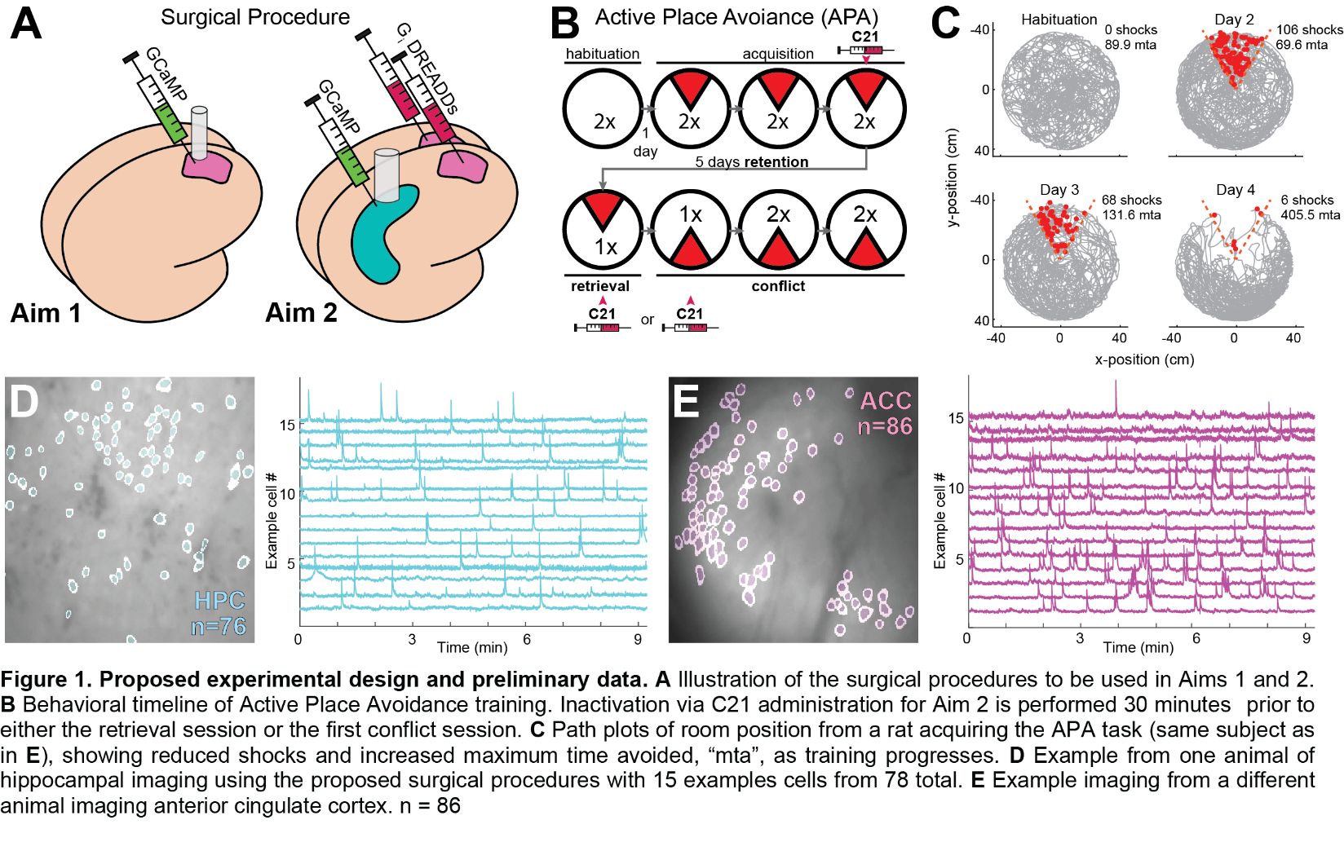**APPROACH**

**Figure 2. Proposed experimental design and preliminary data. A** Illustration of the surgical procedures to be used in Aims 1 and 2. **B** Behavioral timeline of Active Place Avoidance training. Inactivation via C21 administration for Aim 2 is performed 30 minutes prior to either the final acquisition session, the retrieval session, or the first conflict session. **C** Path plots (grey) of room position with shock times in red from a rat acquiring active place avoidance (same subject as in **E**), showing number of shocks and max time avoided (mta). **D** Cropped example imaging (extracted contours overlaid in blue) from the HPC of a rat during APA with 15 example cell fluorescence activity plotted to the right (76 cells total). **E** As in D, imaging from ACC from a different rat with 15 example cells to the right (86 cells).

Adult Long-Evans rats (3-6 months old) will be used in these aims with equal gender balance in all aims though no significant difference of gender is anticipated. I will utilize in-vivo single photon calcium imaging and chemogenetics to study cognitive control in the brain. Calcium imaging is an indirect yet informative measure of neuronal activity that enables us to record calcium dependent fluorescence activity from hundreds of neurons simultaneously. I will apply this in either the anterior cingulate cortex (ACC, Aim 1) or hippocampus (HPC, Aim 2) while animals perform a cognitive control task (Fig. 2A). This is an imaging technique that I have pioneered in rats during my previous doctoral research that enables stable recordings of the same cell populations across many weeks without restricting behavior22,63,66,101,102. This will enable us to record from the same region during different phases of the active place avoidance task (Fig. 2B). I will evaluate whether the cognitive control signal previously demonstrated in the HPC is also present in the ACC (Aim 1), and how the cognitive control is influenced by ACC activity (Aim 2).

**Behavior**

Active Place Avoidance is a cognitive control task wherein the animal must selectively attend to cues which predict shock (stationary room cues) while ignoring the local arena cues that have no predictive value for avoidance. The animal is placed in an open field arena (80 cm diameter) which slowly rotates at 1 rpm while the animal explores. This rotation dissociates the open field into two overlapping reference frames: the animal can either localize itself within the frame of the arena using immediate proximal cues (*arena frame*) or localize itself relative to the distal visual/auditory cues (*room frame*). A mild 0.2 mA shock is delivered when the animal is within a certain part of the room (a northern 60° sector, Fig. 2B), so the animal must learn to avoid that area while constantly being drawn towards it due to the arena rotation. This mild shock elicits avoidance from the shock zone without causing freezing or increased corticosterone in the context, which is critical for the study of hippocampal function103. Decades of research has shown that mice and rats can readily learn this task and it is dependent on bilateral HPC activity8,78. Importantly, because this task necessitates flexibly attending to the proper shock-predicting cues (room) while ignoring distractors cues (arena) within the same spatial environment, it is the perfect task for studying the neural basis of cognitive control7,11,89.

Rats will be given two 20-minute recording sessions every day during active place avoidance training (Figure 2B) with a 30-minute inter-session interval. Day 1 is a habituation session to the rotating environment, while days 2-4 are training sessions. After the last training day, rats will be given a 5-day retention interval. Day 10 consists of a single retrieval session (with shock), and Day 11 a single conflict training, where the shock zone is located 180° away from the initial learning position. Shock is used during the retrieval session to avoid extinction that would otherwise occur and subsequently confound conflict training. Day 12-14 will continue conflict training with two 20 min sessions each day. This experimental design enables us to reliably and rigorously test ACC necessity during specific behavioral phases (acquisition, retrieval, and conflict learning).

**Data analysis**

**Calcium imaging:** Data will be analyzed using previously published procedures in python and MATLAB66,104. Briefly, motion artifacts are corrected using NoRMCorre105, then source extraction performed using non-negative matrix factorization via CaImAn106–108, where individual cells within the field of view are denoised and separated, and their individual calcium trace is deconvolved to remove the slow decay inherent in calcium fluorescence109–111. After the individual cellular activity is extracted from the imaging, deconvolved calcium traces will be summed into 250 millisecond bins (Fig. 3B). This binned activity will be used to test for decoding of positional information within the recorded population using a one-vs-all support vector machine with 5-fold cross validation (Fig. 4A-B). Binned activity will also be used to compute the momentary spatial information (Ipos) for each cell within both the arena and room frames88. The relative position information between the two reference frames, ΔIpos, is then computed by the difference of their absolute values and taking the average across the population (Fig. 3C). The spatial frame ensemble preference (SFEP) is calculated by the number of samples in one frame (e.g. ΔIpos>0 for *room*) divided by the total samples (Fig. 4D). Importantly, while we can and will evaluate traditional measures of spatial coding for place cells, such as mutual information and place field dispersion, our analyses do not depend on sub-selecting cells based upon a spatial information criterion (which can remove 50-80% of CA1 cells in calcium imaging63,66,70,112). Previous work has shown that non-spatial CA1 cells still contribute to spatial decoding performance113, and ACC is known to have lower mutual spatial information114,115 while still disambiguating contexts116.

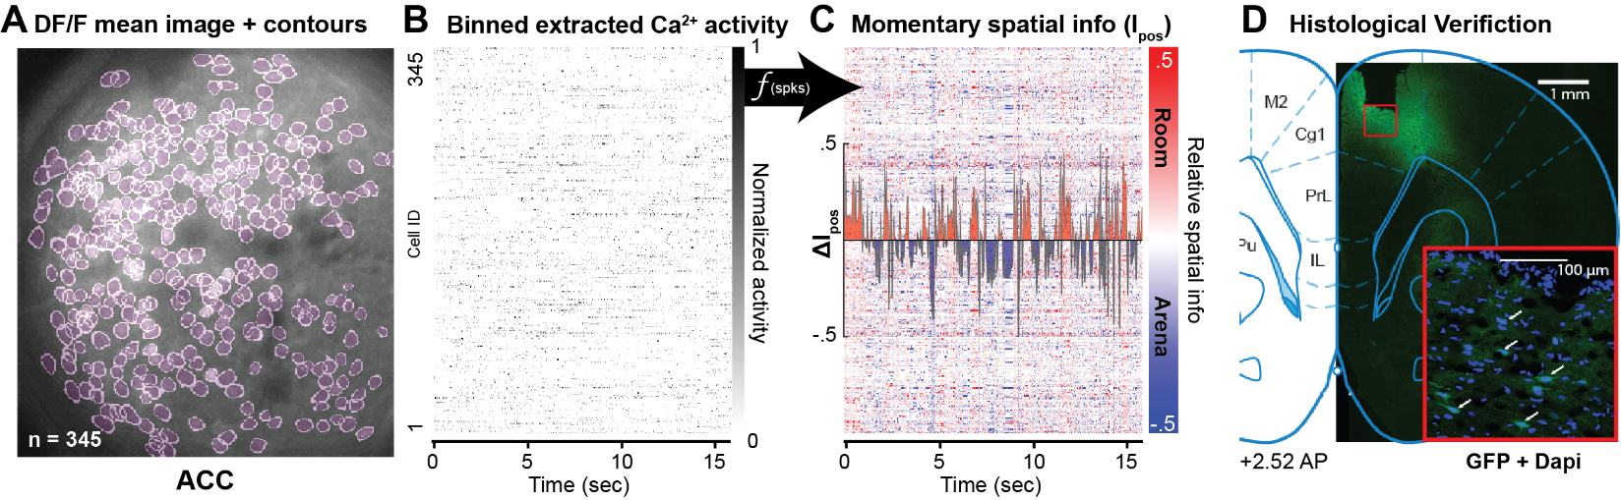**Avoidance Behavior:** Position within the maze is tracked using an overhead camera which tracks an infrared LED mounted on the top of the miniscope. The position of the rotating arena is tracked using an infrared LED mounted on the side on the arena platter. The rat's position within the room frame is evaluated in real-time, and location dependent shock is delivered by a grounded wire tether connected to the rat with the arena acting as the active pole. Avoidance learning within the task is quantified by the total number of zone entrances, time until the first entrance is made, and the maximum time avoided during each session (Fig. 2C). Total entrances and maximum time avoided are used to measure avoidance learning, while time to first entrance measures memory retention.

**Figure 3. Demonstration of ACC calcium imaging and data processing A.** Background subtracted mean frame from a recording in ACC with 345 neurons during early training. Extracted neuron contours are overlaid in magenta **B.** 15 seconds of extracted calcium transients from the recorded session in A, binned in 250 millisecond bins **C.** Visualization of Ipos computed from the binned transients in B (scale is clipped for ease of visualization only). Positive values correspond to momentary spatial information in the room frame, and negative are arena frame **D.** Histological verification of GCaMP8m expression (GFP) and DAPI beneath the lens implanted in ACC.

**Aim 1. Investigate whether the ACC demonstrates a cognitive control signal.**

Research on cognitive control during active place avoidance has revealed a prominent cognitive control signal within the HPC that is important for understanding cognition6,12–14, as well as psychiatric86,100 and developmental disorders affecting executive function7,15,89. While it has been shown that the HPC is necessary for performing this task8,78, it remains unclear what other brain regions contribute to cognitive control. Abundant literature in humans using fMRI has implicates the ACC in cognitive control1,2,17,20,27,117, and highlight the importance of interactions between HPC and ACC (along with other prefrontal regions) during cognitive control when tasks necessitate episodic retrieval44,46,99. Rodent and primate studies support the role of ACC in cognitive control21,98,117–120 and action-outcome decision making22,41,121–123. The prefrontal cortex has additionally been theorized to act as an action-selection guide during navigation37,99, avoidance124, and memory retrieval45,125–127. Thus, the ACC is the ideal target for evaluating a prefrontal neural representation of cognitive control that could guide HPC activity. Yet a proper mechanistic explanation has not been demonstrated within this region like it has been for HPC. By recording calcium imaging from ACC while rats perform a cognitive control task, we will determine if a cognitive control signal is similarly represented, providing an essential key component for understanding cognitive control.

**Figure 4. Preliminary recordings of a cognitive control signal within ACC. A** Demonstration of decoding angular position from extracted calcium activity recorded in ACC. **B** Summary of the decoding performance from 3 animals compared to chance based on shuffled activity. All recordings consistently perform better than chance. **C** (Top) Plot of the rat’s distance from the shock zone during active place avoidance from a late acquisition session when behavior is well learned, highlighting successful avoidance in green and shocks in magenta. (Bottom) Extracted ΔIpos from this session. Prior to successful avoidance, ΔIpos is greater than 0 (room representation), and the opposite trend is present during errors. Inset pie graph depicts spatial frame ensemble preference (SFEP) for this session. **D** Summary of SFEP during early and late active place avoidance (same sessions in **B**) in HPC and ACC.

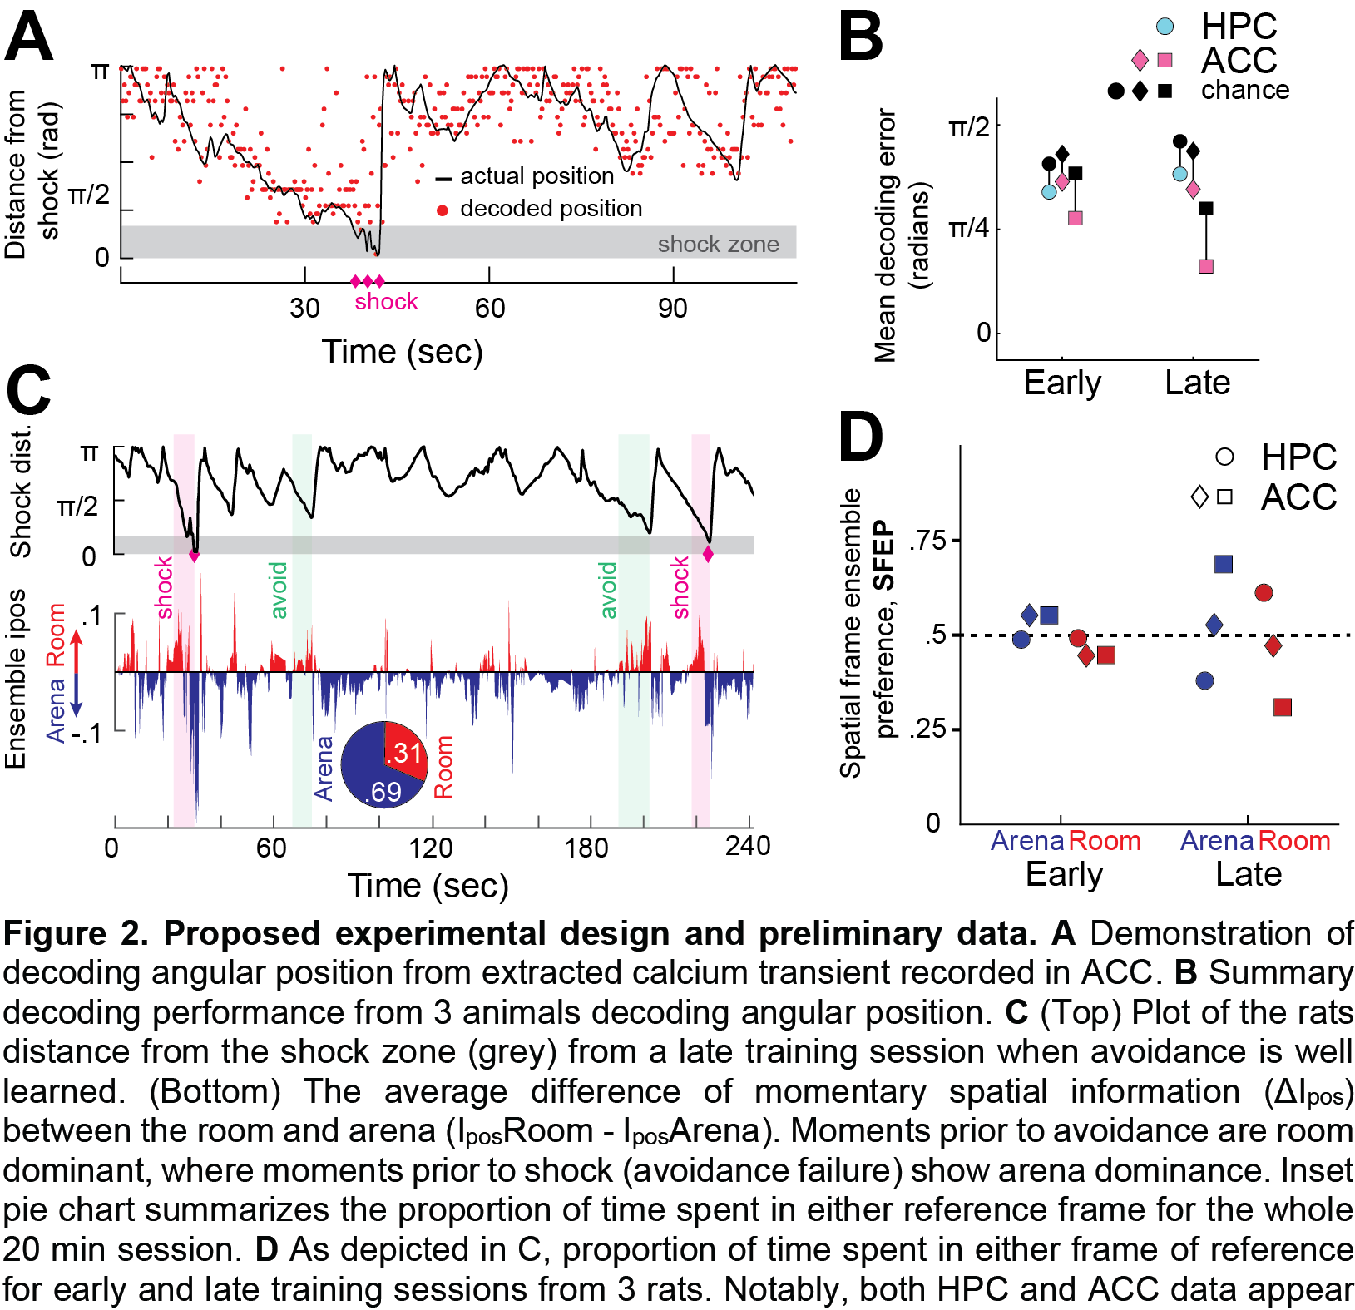**Preliminary data**

Initial recordings demonstrate that this cognitive control signal can be recorded from the rat ACC using calcium imaging (Fig. 3C). This is the first evidence of a cognitive control signal outside of the hippocampal formation and entorhinal cortex during active place avoidance in rodents. Calcium imaging recordings during acquisition of active place avoidance and after the task has been well learned not only demonstrate a prominent cognitive control signal, but this signal developed a relationship after the task was well learned (Fig. 4C-D). Such a learning correlate has also been described in HPC activity35. This aim will provide a definitive description of the presence of a cognitive control signal during active place avoidance, and extend evaluation into retrieval and conflict training.

**Surgical procedure**

Rats will be anesthetized with isoflurane and maintained at 2-3% while 1.0 μL of AAV9-CamKIIa-jGCaMP8m-WPRE is infused into the dorsal ACC (+2.0AP, 0.7ML, 1.4DV). After waiting for 30 minutes to allow the virus to diffuse, a 0.8 mm ball drill bit will be slowly lowered to 1.6DV over two minutes, then a 1.0mm diameter Gradient Refractive INdex (GRIN) lens will be implanted at 1.8 mm below skull surface (following my previously published procedures22). At the end of surgery, and for 5 days after, post-operative analgesia is given via subcutaneous injections of carprofen (5 mg/kg) and inflammation reduced by daily doses of dexamethasone (.1 mg/kg). Rats will also be given bacon flavored antibiotic medicated chow (Baytril, 2 mg/kg pellets) during this period to further minimize infection chance. Rats are given two weeks after surgery to recover, after which they will be put under light anesthesia in order to secure a baseplate above each implanted lens that will hold the miniature microscopes (“miniscopes”104,128,129) used for recording calcium imaging. Training of the active place avoidance behavior will begin 1 week after baseplating.

In a subset of animals, I will also attempt to implant an additional lens above the ipsilateral HPC CA1 (following implant procedures of Aim 2). This dual site imaging would allow us to simultaneously record activity from the two regions33,130 and evaluate any coordination of activity across brain regions that likely serves cognitive control. However, since this approach has not yet been demonstrated in our hands, neither aim is dependent on this dual site method. This would be abandoned if it appeared to negatively affect animal health, performance, or ACC imaging success an would not impact progress toward completing aim 1.

**Expected Outcomes**

Previous research from our lab has shown that this active place avoidance training will produce robust learning that persists across the retention period, yet can be updated following conflict training35. This learning has been previously shown to persist across at least a 60-day retention interval7. Rats will significantly improve their avoidance behavior (measured by number of entrances and maximum time avoided) as training progresses, which will be maintained across retention (measured by time to first entrance), and be significantly worse on the first conflict training (for all three measures). However, after the first conflict session rats will rapidly update to the new shock zone location. Behavior will be quantified by using a paired t-tests of these measures compared to the second habituation session. Preliminary recordings suggest we will confirm the existence of a cognitive control signal in ACC, quantified as ΔIpos. A runs test will determine the statistical likelihood of ΔIpos (compared to a stochastic deviation). As described already in HPC, this signal will develop a significant negative correlation with avoidance following learning and preferentially represent the frame of reference based on proximity to the shock zone15,16. Specifically, ΔIpos>0 when near the room shock zone, and ΔIpos<0 when further away. Importantly, this relationship will be true during successful avoidance, and not true during errors (periods of time just before shock entrance, ΔIpos<0), thus not correlated prior to entrances. As the behavior becomes well learned, ΔIpos<0 a majority of time, and increase above zero only when needed for avoidant behavior (Fig. 4C-D). A t-test from habituation will show SFEP divergence from 0.5 as learning occurs (Fig 4D), as seen in prior recordings (Fig 5D).

**Potential Pitfalls and Alternative Strategies**

While there is already evidence suggesting its existence, we may be unable to definitively demonstrate a cognitive control signal within ACC. This may be caused by a lack of task difficulty to substantially engage the prefrontal cortex, in which case we would add an additional shock zone tied to the arena frame4,5. This two frame active place avoidance task would necessitate greater attention and cognitive load, which are known to depend on and engage ACC22,91,131. On the other hand, if we do confirm a cognitive control signal within ACC, while it will be of interest to compare to previous results from HPC, it could be beneficial to compare them with a group of animals trained in a non-cognitive control task using a behaviorally yoked control design to tease out the effect of cognitive control learning against shock exposure alone. Future studies motivated by this aim would seek to perform simultaneous recordings in both ACC and HPC during this task to evaluate any correspondence between the two regions, which would be the next logical step when attempting to understand how cognitive control is managed by different brain regions.

**Aim 2. Evaluate the influence of ACC activity on HPC ensemble dynamics during active place avoidance.**

Recent work from our lab has shown that the medial prefrontal cortex (mPFC, including ACC, infra- and prelimbic cortices) is not necessary for the acquisition of active place avoidance35, summarized in Fig. 5. The apparent lack of necessity of the mPFC contradicts current theory of prefrontal cortex in executive function and cognitive control1,20,99. This study used ibotenic acid to lesion the mPFC and recorded single-unit activity in CA1 and showed that learning and the hippocampal cognitive control signal were not affected compared to sham animals. These pre-learning excitotoxic lesions are important for understanding the mPFC’s necessity in acquisition, but it could likely contribute to cognitive control if it was active during acquisition. Similar concepts have been seen in other brain regions. The HPC is not necessary for contextual fear learning132–136, but is necessary for retrieval after normal learning134, suggesting that the brain has alternative compensatory mechanisms if one is unavailable137. By using temporally specific and reversible lesions we can probe the contributions of ACC to cognitive control at later behavioral epochs. To achieve this selective inactivation, I will use Designer Receptors Exclusively activated by Designer Drugs (DREADDs), a chemogenetic tool which enables researchers to reversibly manipulate a neural population within a given brain region in a time dependent manner138,139. It allows temporally specific inhibition of excitatory (CaMKIIa) cells within ACC during the session of interest, which I have previously used to disrupt context-dependent decision making22.

**Preliminary data**

Initial recordings demonstrate that this cognitive control signal can be recorded from the rat HPC using calcium imaging (Fig. 2D and Fig. 4D). This provides evidence of feasibility for calcium imaging evaluating cognitive control within the HPC, which had not previously been shown in the rat. Interestingly, while SFEP for ACC data showed a similar progression during learning as previous HPC data from our lab35, this HPC example showed the opposite pattern: during late training, SFEP was primarily room representing. Notably, this animal also showed poor avoidance performance at this stage (not shown), which may explain this inverse pattern compared to the well performing ACC animals. As with the preliminary data for ACC, current data comes from acquisition and well-trained performance, and will be important to extend this to retrieval and conflict training to see how it compares with previous research.

**Surgical Procedure**

Rats will be anesthetized with isoflurane and maintained at 2-3% while 1.0 μL of AAV9-CamKIIa-jGCaMP8m-WPRE is infused into the dorsal CA1 (-3.6AP, 2.5ML, 2.6DV) and 0.5 μL of AAV8-CaMKIIa-hM4D(Gi)-mCherry will be bilaterally infused into dorsal ACC (2.0AP, 0.7ML, 1.4DV; as in22). Non-DREADD 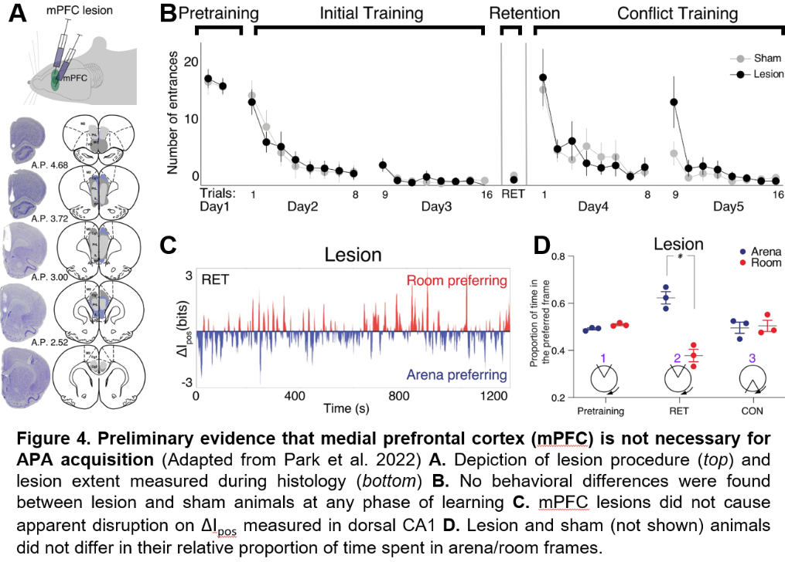expressing control animals will instead be injected with 0.5 μL of AAV8-CaMKIIa-mCherry to serve as comparisons that control for C21 injection effects. After 30 min diffusion period, cortex above CA1 injection will be aspirated and a 1.8 mm GRIN lens will be implanted 0.2 mm above the injection site66,104. Postoperative procedures will follow those described for Aim 1.

**DREADDs inhibition**

I will use DREADDs to selectively inactivate CaMKII-expressing neurons within ACC to evaluate its impact on cognitive control. I have chosen to use the CaMKII promoter for both the calcium imaging and chemogenetics as it preferentially labels excitatory neurons140 and has been previously used to evaluate ACC’s role in decision making22. Compound 21 (C21) will be used as the exogenous ligand for the DREADDs inactivation. Intraperitoneal injection of C21 (1 mg/kg) will occur 30 minutes before either 1) the second session of day 4 (late training) 2) retrieval or 3) conflict training. This dosage of C21 has been demonstrated to provide sufficient brain penetrance to activate hM4Di while avoiding off-target effects (such as back-propagation of clozapine-N-oxide to clozapine)141. Both the hM4Di and control animals will receive C21 administration to control for unintended confounds of injection.

**Figure 5.** **Preliminary evidence that medial prefrontal cortex (mPFC) is not necessary for active place avoidance** (Adapted from Park et al. 2022) **A.** Depiction of lesion procedure (top) and lesion extent measured during histology (bottom) **B.** No behavioral differences were found between lesion and sham animals at any phase of learning **C.** mPFC lesions did not cause apparent disruption on ΔIpos measured in dorsal CA1 **D.** Lesion and sham (not shown) animals did not differ in their relative proportion of time spent in arena/room frames.

**Expected Outcomes**

Based on the established functional interactions between ACC and HPC during cognitive control, I anticipate that disrupting their communication at all time points (either late acquisition, retrieval, or conflict training) will disrupt avoidance behavior, but for different reasons. Inhibition of excitatory neurons within ACC via C21 administration prior to late acquisition will cause hM4di animals to significantly increase the entrances to the shock zone and significantly decrease their maximum time avoided (A significant interaction in the AVONA with group and session, followed up with a paired t-test). This could be attributable to a loss of the action-selection guidance that developed during acquisition42,142. ACC inhibition during the retrieval session will cause a similar significant deficit in time to first entry compared to control animals, but this would be attributable to the suppression of the remote memory representation that is believed to consolidate in the ACC during the retrieval interval and utilized for recall32,33,125,126. Finally, inactivation during the initial conflict training session will disrupt the behavioral updating that is necessary by inhibiting the role of the ACC in performance monitoring during cognitive control23,24,26,27,143. Control animals will be faster to update their avoidance behavior, showing significantly greater avoidance in the latter half of the session compared to the hM4Di animals. This effect will be most evident when comparing avoidance behavior on the subsequent day, with control animals displaying significantly better avoidance (fewer entrances and greater max time avoided) compared to the hM4Di group. However, this does not rule out an effect of post-learning consolidation being disrupted as well144,145. Inhibition of ACC will also impair the HPC cognitive control signal (ΔIpos) in rats with imaging, measured by a runs test, likely because it had developed during learning dependent on ACC.

**Potential Pitfalls and Alternative Strategies**

If DREADDs does not prove to be an effective or reliable inactivation method, we could alternatively use local infusions of muscimol91,120 or tetrodotoxin8,74,78. While this would be less ideal since these methods also affect fibers of passage and increase bulk on the skull, they would still be useful for understanding the contribution of ACC to hippocampal cognitive control. Furthermore, while we have confidence in this surgical plan, it is possible that simultaneous HPC recordings with ACC manipulations is not consistent enough to yield enough data within the funding timeline. For that reason, the core hypotheses of this aim (does ACC activity support cognitive control during active place avoidance) primarily depends on the behavioral effects caused by the inactivation manipulation. Calcium imaging in CA1 will provide a greater means of relating any effects to previous research, but is not critical for the success of the aim, so non-imaging viable rats will still be useful for behavioral data.